[District Name]
[District Address]
[Date]

Dear Families,
Your child recently took the Pearson Review of Progress & Learning (PRoPL), which is a short assessment designed to provide information about what they have learned so far this school year. PRoPL is administered in the fall, winter, and spring in both reading and math. Students take PRoPL online, and teachers receive the results immediately.
PRoPL provides a measure of how well your child is performing in reading and math, as well as specific areas of strengths and where your child needs additional support. We believe that all growth should be celebrated and talking with your child about their progress provides a great opportunity for them to engage with their learning. PRoPL also provides a score that shows growth or progress in their learning from the fall to the winter and from the winter to the spring.
The PRoPL reports contain information that can also support conversations with your child’s teacher about their learning. This provides an opportunity for you to ask questions regarding what the scores mean, how you can help at home, and what types of strategies will be implemented at school to support your child.
Students in grades 3-8 will be provided with a Lexile score for reading and a Quantile score for math on the PRoPL reports. For extra support at home, families can register for a free account at https://hub.lexile.com/ where you will have free access to learning resources. By accessing the link, families can enter the Lexile or Quantile score to find resources that are aligned to your child’s reading or math level. These free resources are available to all families and contain summer activities, book recommendations, and other valuable learning tools.
PRoPL is just one assessment teachers use throughout the year, in addition to monitoring grades and other information, to understand how to best address your child’s educational needs. If you have any questions, please reach out to your child’s teacher. We appreciate your support.
Sincerely,

[District Representative]

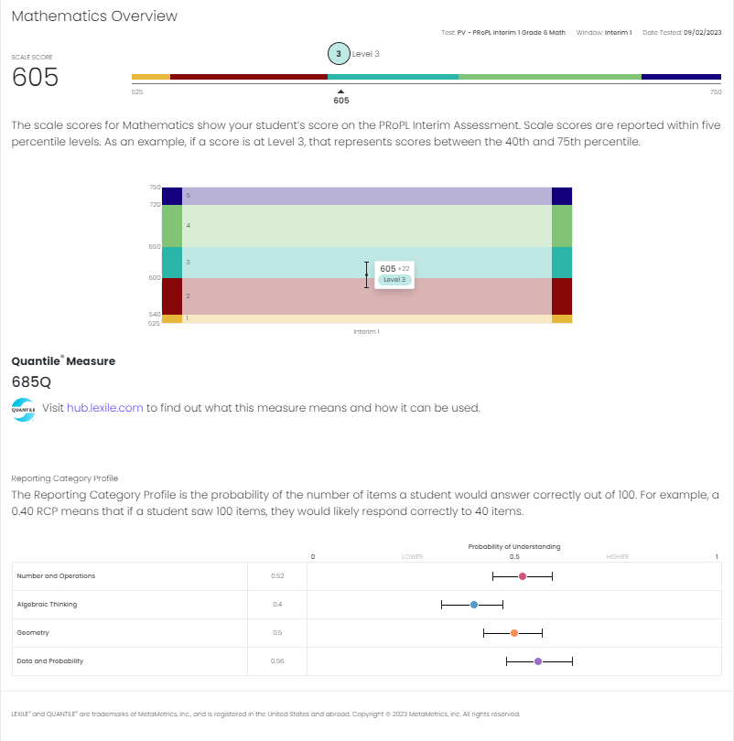
Link to free instructional resources.
Your child’s strengths and areas for additional support.
Your child’s overall performance level out of 5 levels.
Your child’s overall score
Tips for talking with your child about these results.
- Celebrate strengths by reviewing the Reporting Category Profile.
- Explain that this test measures growth so the next report will show how much progress they’ve made.
- Let them know that this is just one test and that teachers will use this information with grades and other types of information to personalize their instruction.

