[District Name]
[District Address]
[Date]

Dear Families,
Your child recently took the Pearson Review of Progress & Learning (PRoPL), which is a short assessment designed to provide information about what they have learned so far this school year. PRoPL is administered in the fall, winter, and spring in either reading or math or in both subjects. Students take PRoPL online, and teachers receive the results immediately.
PRoPL provides both the number of test questions students answered correctly (raw score) as well as scale score. Scale scores are based on raw scores, but which have been adjusted statistically to enable comparisons of student performance across tests within a subject area and grade level.
The PRoPL reports contain information that can also support conversations with your child’s teacher about their learning. This provides an opportunity for you to ask questions regarding what the scores mean, how you can help at home, and what types of strategies will be implemented at school to support your child.
PRoPL is just one assessment teachers use throughout the year, in addition to monitoring grades and other information, to understand how to best address your child’s needs. If you have any questions, please reach out to your child’s teacher. We appreciate your support.
Sincerely,

[District Representative]

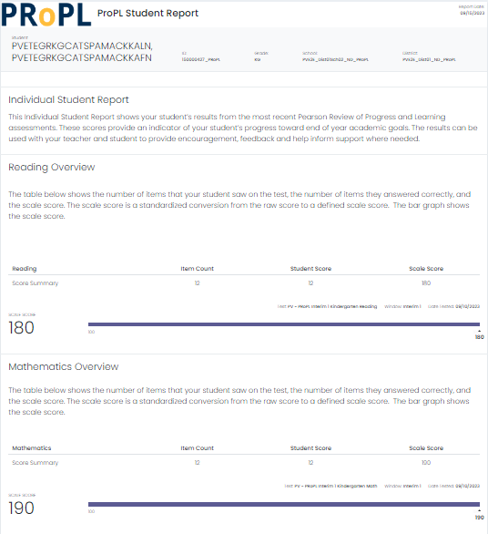
Subject area of assessment.
Scale score range
Number correct converted to scale score.
Number of items correct.
Number of items on the assessment.
Tips for talking with your child about these results.
- Online, standardized assessments may be new to your child. Celebrate their success!
- Explain that this test measures growth so the next report will show how much progress they’ve made.
- Let them know that this is just one test and that teachers will use this information with grades and other types of information to help them at school.

