Best Practices for Successful Assessment Administration with Schoolnet
Customization suggestions for this document: Replace all text in red with site-specific information. Review and adjust text in green for applicability: for example, do your tests have open response items, some students testing on paper, secure tester, text-to-speech, etc. Once customized, distribute to teachers and staff, including posting to this document locally and link to it from the My Schoolnet page (for tips on how to do this, see the Configuring the Home Page Quick Reference Card.)

Please review this document in advance of student testing. Referenced documents are available on the Schoolnet Training Management site: on your first visit only you will be prompted to enter an email and for institution, enter [district name]. The referenced titles in this document here are hyperlinked, but you may find it faster to browse by name and category in the List view to avoid needing to reenter your email.

Know these Important Dates
- Assessment Window: Feb 20 – March 16, 8 am – 5 pm, M – F only
- Scoring Due Date: March 16

Preparing for the Assessment
- If students will be using any computers or tablets that weren’t used for a previous Schoolnet assessment, review the System Requirements page, available from the Schoolnet site footer.
- Confirm that pop-up blockers will not impede access to the Schoolnet site; “whitelist” if needed
- If students will be testing in a lab, confirm the network password (if applicable) in case a student signs off the computer
- Text-to-speech is available on [math/ELA/other] for [some/all] students, so plan accordingly for headsets.
- Indicate if any accommodations will be available for all students, such as calculators on some or all tests. Some students will be granted additional accommodations based on their Personal Needs Profile. See also Administering Assessment with Accommodations in TestNav

- Each test has a unique online test passcode. Please be sure each student uses the correct passcode for the assessment they are supposed to take. To access the right code, select the class on the home page and click the Test Management tab in the Classroom Assessment Monitor. This code is also available on the Test Detail page: click the Assessment Dashboard link.
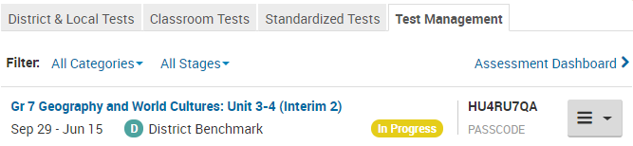
Contains link to Proctor Dashboard
Link to test-specific online passcode

Proctoring the Assessment
- Indicate here if the test must be used with secure tester.
- If this is a browser test, indicate if you recommend a specific browser (for example, if you have disabled pop-up blocker on only the recommended browser)
- Explain how students will log in to test and how to find usernames/passwords if applicable
  - Students log in to their portal select the “Applications” button in the top right corner, and then select Schoolnet from the list.
- Let students know what to do if they encounter internet issues during test (see also: Understanding Internet Connectivity and Online Testing in TestNav)
- The link to the Proctor Dashboard is available starting the first day of the test window.
- Students have 90 minutes for the assessments.
  - It is suggested that students complete their tests in one sitting.
  - If the school schedule does not allow for this, students must click the PAUSE button to exit their test so they can resume it later.
- Text-to-speech is available for all students for math, for ELA, the proctor should read aloud to any student who should get this accommodation.
- Any other assigned accommodations, such line readers or reverse contrast, are granted automatically in the system.
- When students are finished testing, review the Proctor Dashboard to make sure they submit their test.
- For details about the new submit function, resuming a test submitted prematurely, and more, refer to the Administering TestNav Assessments Quick Reference Card.
Scoring Open Response Items
- All scores should be entered by [date]
- When scoring, for each student verify you are scoring for the correct class the test is assigned to in order to avoid altering how scores appear for reporting. Also be sure to save your scores.
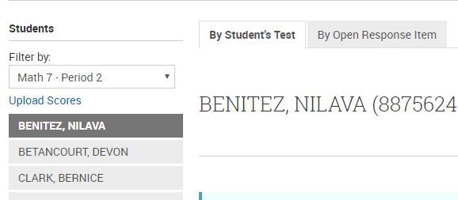
- For details on scoring, refer to the Scoring Open Response Items Quick Reference Card
Viewing Results
- Although results are available for reporting as soon as students submit their test, be aware that open response items default to zero until they are scored.
- Although classroom-level reports and the Benchmark Reporting Dashboard reflect real-time data, some school level reports require overnight processing, so during the test window numbers may not match on all reports.
- If you are a teacher new to Schoolnet, be sure to review Getting Started with Classroom-level Reporting Quick Reference Card.

Questions?
- For network issues, contact [xxxxxxxxxxxx]
- For questions about student usernames and passwords contact [xxxxxxxxxxxx]
- If you have questions about the content of the assessments contact [xxxxxxxxxxxx]
- If you have questions about who takes what test or accommodations contact [xxxxxxxxxxxx]

